**Preparation for the Test#1 (CSC 142)**

1. **What is the result of each of the following expressions?**

**int x = 42, y = 17, z = 25;**

* 1. **y < x && y <= z**
  2. **x % 2 == y % 2 || x % 2 == z % 2**
  3. **x <= y + z && x >= y + z**
  4. **!(x < y && x < z)**
  5. **(x + y) % 2 == 0 || !((z - y) % 2 == 0)**

1. **Parameter Mystery**

Consider the following program.

**public class Mystery {**

**public static void main(String[] args) {**

**String she = "it";**

**String it = "her";**

**String her = "you";**

**String you = "she";**

**saying(you, it, you);**

**saying(it, her, she);**

**saying(she, "you", her);**

**saying(it, "him", "fred");**

**}**

**public static void saying(String it, String her, String she) {**

**System.out.println(she +" can't take "+ it+" with " + her);**

**}**

**}**

1. **Write a method quadrant that accepts a pair of real numbers x and y and returns the quadrant for that point:**

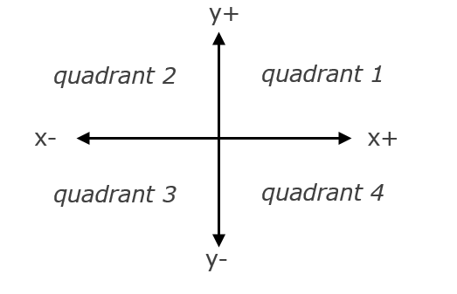

* + Example: quadrant(-4.2, 17.3) returns 2

If the point falls directly on either axis, return 0.

1. **Write what this code will display** 
   1. number=10 answer:
   2. b. number=12 answer:

**public static int countMethod(int number) {**

**int count = 0;**

**for (int i = 2; i < number; i++) {**

**if (number % i == 0) {**

**count++;**

**}**

**}**

**return count;**

**}**

1. **Write what this code will display** 
   1. n=13 answer:
   2. n=25 answer:

**public static boolean isMethod(int n) {**

**int count = 0;**

**for (int i = 1; i <= n; i++) {**

**if (n % i == 0) {**

**count ++;**

**}**

**}**

**if (count == 2) {**

**return true;**

**} else {**

**return false;**

**}**

**}**

1. **Write a method comboString that accepts two parameters a and b, return a string of the form short+long+short, with the shorter string on the outside and the longer string on the inside. The strings will not be the same length, but they may be empty (length 0).**

**comboString("Hello", "hi") → "hiHellohi"  
comboString("hi", "Hello") → "hiHellohi"  
comboString("aaa", "b") → "baaab"**